Rockwell Community Nursing Home

Newsletter 2024

Welcome Spring!

I think everyone is ready for the snow to be gone and for the flowers to start blooming. We will be starting van rides soon so please let Hailey or Trish know if you would like to go on a van ride! We will be making a sign up sheet weekly for scheduled van rides so make sure you get on the list!

This month we will be celebrating Earth Day on the 22nd by having some “dirt cups”. It is also Occupational Therapy Month, Administrative Professionals Day, and Volunteer Appreciation Week this month. Volunteers, please be on the lookout for an invite to our Volunteer Social that the resident’s will be hosting at the end of this month!

On Sunday, April 14th, it is National Gardening Day. The residents will be potting their very own flowers to keep in their room, dining room, or activity room. We always enjoy having flowers to watch grow. Next month we will be having a meeting about what we would like to plant in our garden this year. The garden went over very well last year and the residents enjoyed being able to have fresh veggies at their meals.

As the weather starts getting warmer and the garden is getting closer to opening, please make sure your family member has a hat or sunglasses that they can wear to block the sun for those garden days!

We are very excited to be able to start outdoor activities, van rides, and relaxing in the garden here soon!

Hailey & Trish

Below is the Care Conference schedule for the month of April and early May. We invite family members to attend, so please call to schedule a time. For your convenience and ours, we limit the time to 30 minutes per conference.

Thursday April 4th Thursday April 11th Thursday April 18th

Peggy Jones John Chaddock No Care Conference

Dorothy Johnson Jeffery Boyes

Audrey Harder Kathleen Hansen

Thursday April 25th Thursday May 2nd Thursday May 9th

Agnes Voss Joyce Trimbell No Care Conference

Dorothy Poland Janice Fullerton

Julie Montag Dennis Huntbatch

Employee April Birthdays Employee April Anniversaries

Abie Freyholtz 6th Denise Martin 17 years

Denise Martin 12th

Sarah Dusold 13th

Rachel Dusold 21st

Bridget Riser 27th

Amy White 27th

The resident’s filled easter eggs for the community easter egg hunt that was held at Zeidler Park!
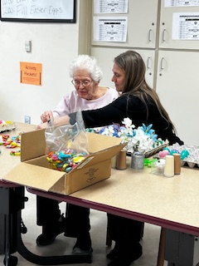
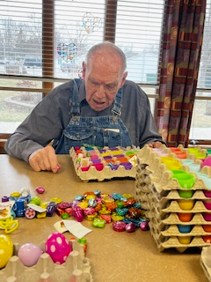
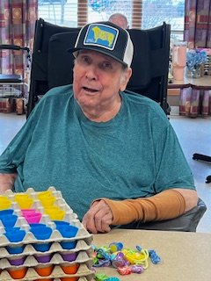
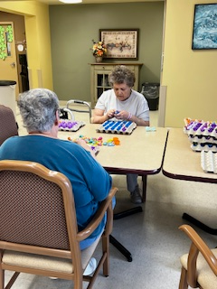

National Volunteer Week: April 21st – 27th

Volunteers give freely of their time and skills to serve the needs of others. We here at the Rockwell Nursing Home would like to thank the countless people who volunteer selflessly every day. We certainly could not operate without you.

THANK YOU!

Hello from Nursing…
Multidrug-resistant organism transmission (MDRO) is common in long term care facilities. Many residents in nursing homes are at increased risk of becoming colonized and developing infections with MDRO’s.
Centers for Medicare and Medicaid, also known as CMS has recently brought out new guidance/recommendations on Enhanced Barrier Precautions (EBP) for resident with chronic wounds or indwelling medical devices (Ex: indwelling catheters, IV’s, PICC, Central lines) during high-contact resident care activities, which include: dressing, bathing, transferring, providing hygiene, changing linens, assisting with toileting, wound care and device care.
Residents will not be restricted to their rooms or limited in participation in group activities.
We are using Enhanced Barrier Precautions to help protect our residents from infection. You may see signs throughout the facility and staff wearing gowns and gloves for high-contact care activities.
We are taking action to protect our residents from dangerous germs. These germs can cause infections that are hard to treat.
Enhanced Barrier Precautions allow us to provide safe, high-quality care and help stop the spread of germs within our facility.
You can help stop the spread of germs by cleaning your hands with alcohol-based hand sanitizer or soap and water.
There is also new guidance on the COVID 2023-2024 vaccine that recommends anyone over the age of 65 to have a second COVID vaccine four months after the 1st dose. We will be sending out letters and consent form in the next few weeks.
If you have any questions or concerns, please call.
IP team

Sunday | Monday | Tuesday | Wednesday | Thursday | Friday | Saturday
 | 1 | 2 | 3 | 4 | 5 | 6
 | 10:00 Coffee Social  10:30 Exercise  2:00 Swaledale Methodist Bingo | 10:00 One on Ones  1:00 Music w/ Talia  2:15 Spring Craft | 10:15 Bible Study  2:00 Movie  6:30 Take Away Poker | 10:00 Stories w/ Sherry  10:30 Exercise  2:00 Pokeno | 10:15 Rosary  2:00 Quarter Bingo | Independent Activity – “Bored Board”
7 | 8 | 9 | 10 | 11 | 12 | 13
10:00 Music with the St. Peter Lutheran Sunday School Kids | 10:00 Coffee Social  10:30 Exercise  2:00 Rockwell Methodist Bingo | 10:00 One on Ones  1:00 Music w/ Talia  2:15 Yahtzee | 10:15 Methodist Church Service with Pastor Wendy  2:00 Resident of the Month Activity Choice | 10:00 Coffee Social  10:30 Exercise  1:30 Stories w/ Jolynn  2:15 Pokeno | 10:15 Prayer Service w/ Kate  2:00 Quarter Bingo | Independent Activity – “Bored Board”
14 | 15 | 16 | 17 | 18 | 19 | 20
10:00 St. Peter Lutheran Church Service on T.V.  1:00 Flower Potting | 10:00 Coffee Social  10:30 Exercise  2:00 Rockwell Lutheran Bingo | 10:00 One on One’s  1:00 Music w/ Talia  2:15 Baking Class | 10:15 Bible Study with Louise  2:00 Movie  6:30 Take Away Poker | 10:00 Stories w/ Sherry  10:30 Exercise  2:00 Prize Pokeno | 10:15 Mass with Father Josh  2:00 Quarter Bingo | Independent Activity – “Bored Board”
21 | 22 | 23 | 24 | 25 | 26 | 27
10:00 St. Peter Lutheran Church Service on T.V.  National Volunteer Week | 10:00 Coffee Social  10:30 Exercise  2:00 Sacred Heart Bingo | 10:00 One on One’s  1:00 Music w/ Talia  2:15 Volunteer Appreciation Posters for Volunteer Social | 10:15 Hanford Church Service  2:00 Volunteer Social | 10:00 Coffee Social  10:30 Exercise  1:30 Stories w/ Jolynn  2:15 Pokeno | 10:15 Prayer Service w/ Kate  2:00 Quarter Bingo | Independent Activity – “Bored Board”
28 | 29 | 30
10:00 St. Peter Lutheran Church Service on T.V. | 10:00 Coffee Social  10:30 Exercise  2:00 Prize Bingo | 10:00 Coffee Social  10:30 Exercise  2:00 Monthly Birthday Party |  | Earth Day: 22nd | Administrative Professional’s Day: 24th

April 2024

